## How do I use the Canvas Admin Dashboard LTI?

The Canvas Admin Dashboard LTI is created by a team from Professional Learning Studio at Learning and Teaching Center powered by CITE at Northwest Missouri State University. This LTI allows canvas admin monitor the status of Student Information System.

1. How to access the Admin Dashboard LTI?
2. Using the LTI?

**Section 1: How to access the Admin Dashboard LTI?**

1. Login into the canvas site

To use the Admin Dashboard LTI, one need to be canvas admin.

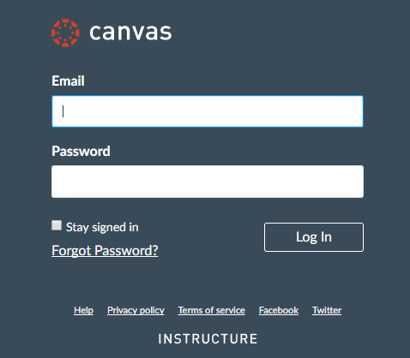

1. After log in view the course site that will be showing up in the canvas. Click on that course site as shown below.

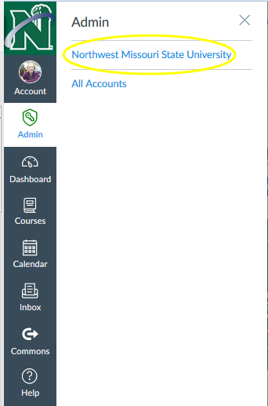

1. Click on the Admin Dashboard LTI as shown below

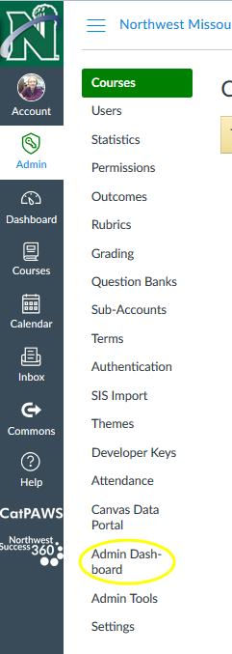

1. Admin Dashboard overview

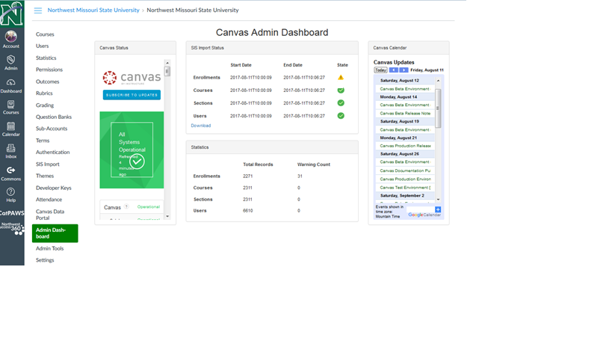

**Section 2: Using the LTI?**

Admin can use this application to monitor the SIS import status

1. Below shows, the status of SIS imports.

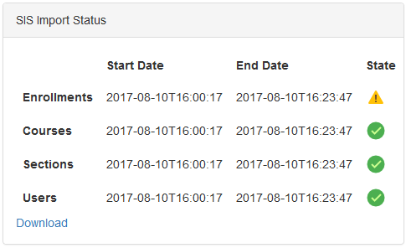

1. Below shows, the statistics of SIS imports.

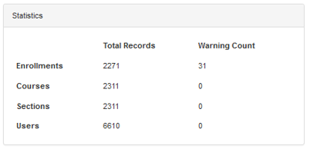

1. Below shows, the status of canvas.

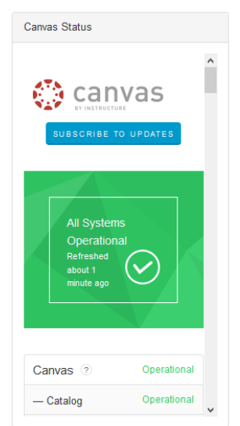

1. Below shows the calendar updates of the canvas

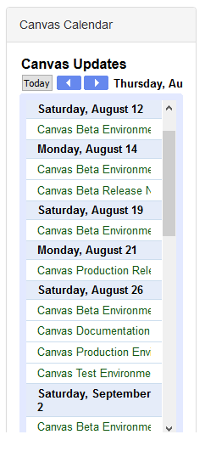

1. Click on the warning icon to as shown below to view the warnings.

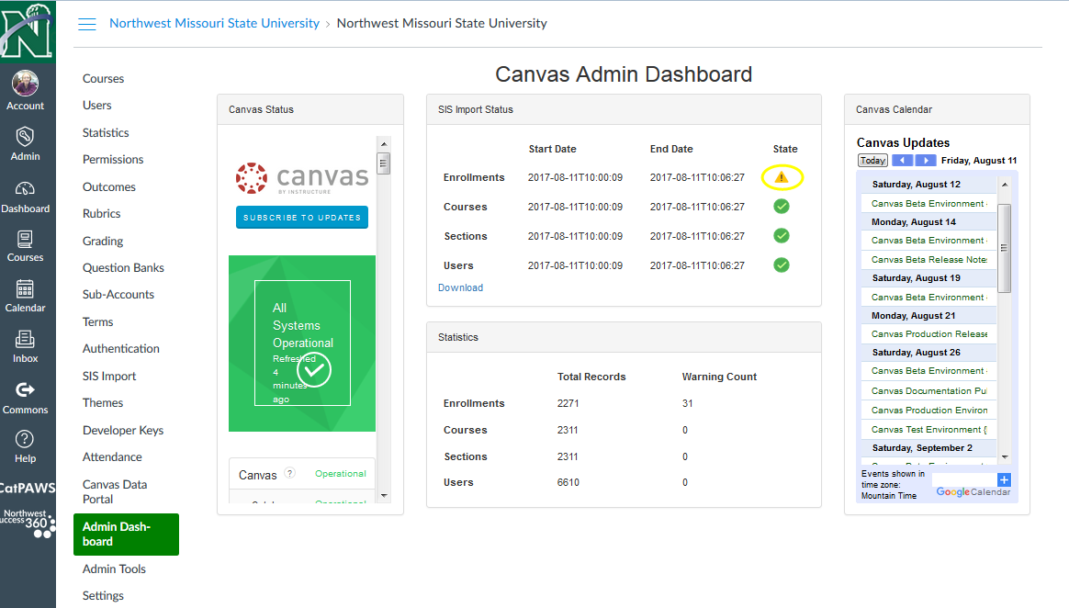

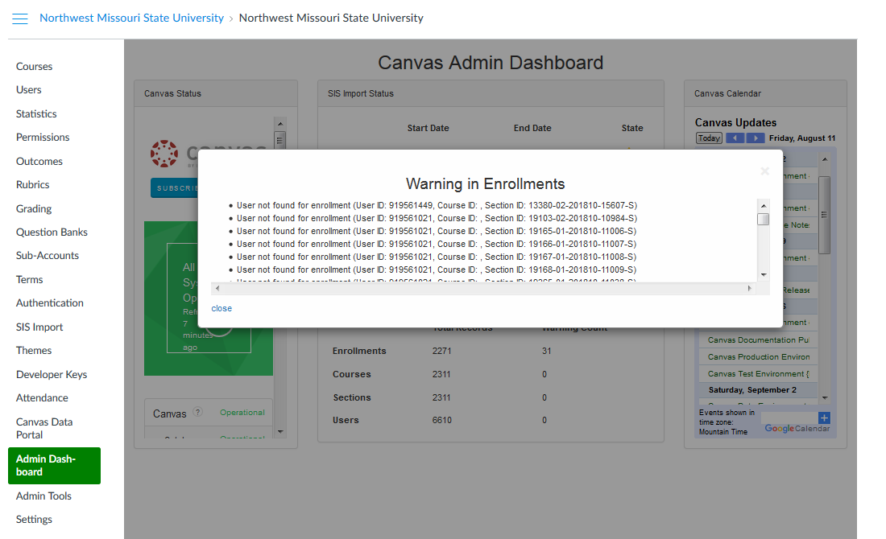

1. Click on the download button to download the excel sheet.

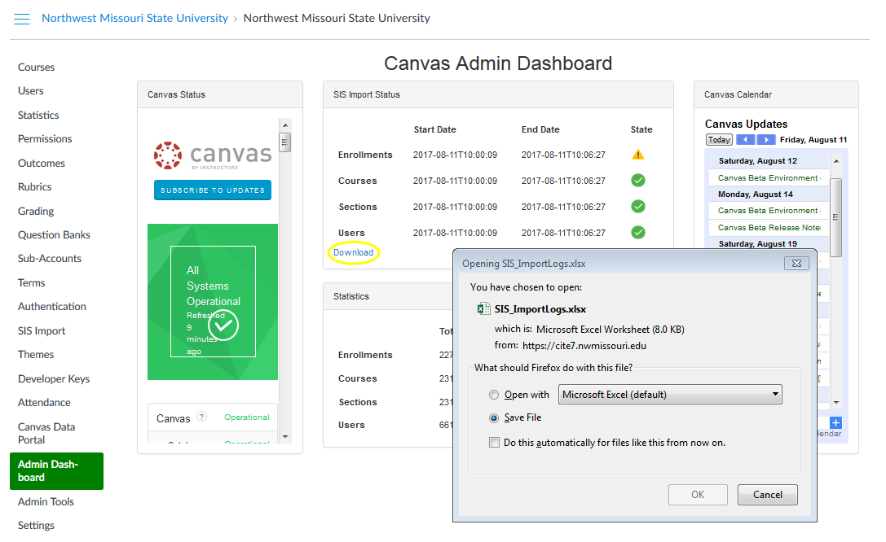

1. The downloaded excel sheet looks as below.

